**Evolt Technology Overview**

**Training Material**

# Contents

1. Contents 2

2. Who are we? 3

3. CONTEXT 5

4. ASTA Scope 7

5. Application Description 7

**Mobile App** 7

**Evolt Kiosk** 7

**Insights Platform** 8

**Insights Admin** 9

ASTA Support Scope 9

6. Structure 10

7. Insights Team 11

8. Evolt Support Team 11

9. Service Level Expectations 12

10. Next Topic 12

# Who are we?

Evolt is a pioneering company specializing in advanced body composition analysis solutions, catering not only to individuals but also offering extensive benefits to our business partners (Customers). Our state-of-the-art technology empowers fitness centres, wellness facilities, and healthcare providers to deliver personalized services, enhance client engagement, and drive business growth.

Below is an image of one of our kiosks in use

**Founded in 2015** by **Ed Zouroudis** and **Kelly Weideman**, **Evolt 360** is a pioneering wellness technology company headquartered in **Southport, Queensland, Australia, but with offices also in Charlston, South Carolina in the USA**. The company specializes in **body composition analysis** and **digital health solutions**, offering a comprehensive ecosystem that empowers individuals and organizations to track, understand, and improve health outcomes. The Evolt 360 is not a weight scale. It is the tool, that empowers you to dive deep into how and where your body is changing as you strive to meet your wellness goals. We provide you the data that informs decisions and inspires you to keep striving to be your best

* **Mission**: To educate people with meaningful insights into their body composition, turning information into inspiration for healthier living.
* **Vision**: To become the most trusted provider in the wellness industry by evolving body composition intelligence and delivering a connected health experience.

Evolt 360’s platform includes:

* **Advanced body composition scanners (The kiosk)**
* A **mobile app** for personalized health tracking
* **Data analytics tools** for health professionals and fitness businesses (Insights Platform)
* Integration with **gamified social environments** to encourage engagement and accountability

Our technology enables users to monitor changes in body composition, activity levels, nutrition, and overall health with precision and ease.

Operating within the **Digital Health** and **HealthTech** sectors, Evolt 360 has grown steadily, now employing over **40 staff** and serving thousands of partners globally. Our prime industry vertical is Fitness. Here we are fortunate to have global agreements with some of the world’s most premium brands, including Anytime Fitness, Worlds Gym, Goodlife and many more

Evolt has received industry recognition for its innovative approach to health monitoring and continues to expand its global footprint in fitness centres, wellness clinics, and corporate health programs. This includes recently being named Health and Wellness Technology company of the year. An award voted on by the industry

While Evolt offers a hardware solution, our core strength lies in being a software and is a data company, which sets us apart in the market. From our humble beginnings, we have grown significantly and are set to list on the Australian Stock Exchange in 2025. This milestone marks the beginning of a new era for Evolt, as we aim to explore new markets and industry verticals with a renewed focus on delivering market leading customer value.

At Evolt, when we refer to "the customer," we mean the thousands of facilities that have purchased an Evolt Kiosk. Our goal is to partner with these facilities to help grow their businesses by integrating our technology into their service ecosystems. These facilities, in turn, serve their own customers, assisting them in achieving their health goals, these are our end users. Our objective is to collect, analyse, and provide actionable data that enhances decision-making for both our customers and their end users

# CONTEXT

The current Evolt apps have passed through a few developers hands, both in-house and Vendor over our 10 year history. The code is a challenge to maintain and test. We have a roadmap which includes a complete transformation of our code base. But for now we are challenged by an ecosystem that is robust, but has its unique behaviours that are frustrating to the Technology/Support team within Evolt and our user base

To that end, Evolt is seeking to leverage the experience of a new partner. A partner that is an industry leader, whose experience we can tap into, to accelerate our own capabilities as a business.

In seeking to work with ASTA we are not looking for “resources” that we need to manage. Rather we are seeking a partner, who can take responsibility and deliver an outcome. As a global company, the location of technical resources is not our concern, it is the outcome we are seeking. We are seeking a partner that does not require micromanaging, is proactive with suggestions and improvements, is agile and can genuinely take work away for the existing stretched for capacity workforce. We require a partner who is part of our inhouse team, who is passionate about our customers as they will be the face of Evolt in a large way

As a scale-up business, **Evolt 360** has been intensely focused on **product development and innovation**. Like many companies in this phase, comprehensive documentation has not always kept pace with our technical progress.

One of the key strengths of the **Evolt–ASTA partnership** will be ASTA’s role in **learning, creating, and enhancing documentation** to deepen our shared knowledge base. This collaboration will help us build a more structured and accessible foundation for both internal teams and external stakeholders.

We are committed to developing documentation that is **clear, simple, and easy to follow**. In the near future, our goal is to transform our current **internal knowledge base** into a **customer-facing resource** that empowers greater self-service and reduces support dependency.

At present, however, the maturity of our documentation is not yet at the level required for public release. This partnership marks a pivotal step toward bridging that gap and delivering a more scalable and user-friendly support experience and result in the first co-created product between ASTA and Evolt

ArchitectureThumbnail Image Create a labeled diagram of the Evolt 360 architecture. The diagram should include the following components:

1. **Evolt Body Scanner** – Hardware device that captures body composition data.
2. **Local Kiosk Software** – Interface for scanning and user interaction.
3. **Internet Connectivity** – Ethernet/Wi-Fi connection to cloud services.
4. **Cloud Infrastructure** – Secure cloud environment for data storage and processing.
5. **Evolt IOH Web Platform** – Admin and operator access to scan data and user management.
6. **Evolt Mobile App** – User-facing app for viewing scan results, tracking progress, and managing account.
7. **Analytics Engine** – Processes scan data to generate insights and reports.
8. **Database** – Stores user profiles, scan history, and configuration settings.
9. **Support & Maintenance Tools** – Remote access, diagnostics, and software updates.

Use arrows to show data flow between components. Style should be clean, modern, and suitable for technical documentation.

# ASTA Scope

The ASTA support services are specifically focused on the following components of the Evolt ecosystem:

* **Native and Web Mobile Applications**
* **Evolt Kiosk Frontend and Control Panel Software**
* **Designated Sections of the Insights Platform**
* **Read-Only Customer Credential Validation**

The following areas are not included within the scope of ASTA services:

* Support for the **Evolt AWS hosting environment**
* Maintenance or troubleshooting of the **Kiosk operating system**
* **Updating customer or user details** via the Insights platform

# Application Description

Evolt’s ecosystem is built around three primary products:

1. **Evolt Kiosk** – Our primary data collection device
2. **Insights Analytics Platform** – A powerful reporting and engagement tool for gyms
3. **Mobile Applications** – Available on iOS, Android, and Web

### **Mobile App**

The Evolt mobile apps provide users with a comprehensive wellness experience. Key functionalities include:

* Account creation and modification
* Wellness goal setting
* Input of essential data (e.g., height) not captured by the Kiosk
* Access to detailed scan results and educational insights
* Historical scan data and trend visualization
* Custom supplement and workout recommendations
* Access to Evolt’s range of supplements and pre-prepared meals (for participating franchises)

### **Evolt Kiosk**

The Kiosk is Evolt’s primary data source, capturing over **80 unique data points** per scan. While Evolt is a software-first company, the Kiosk hardware is a calibrated, medical-grade device.

#### **Customization**

* Some customers use **custom interfaces** (rare) or **custom results sheets** (more common).
* ASTA does not need to be deeply familiar with custom interfaces, as they are stable and rarely generate support tickets.
* Issues with custom results sheets are often linked to the **Kiosk print process**. Diagnosing whether this process is running typically resolves related issues via the Knowledge base article .

#### **Third-Party Integrations**

* **eGym Integration** requires:
  + NFC/QR reader connected before boot
  + API key issued by Evolt
  + Member association via eGym
  + Matching email between Evolt and eGym accounts  
    More details are available in the Knowledge Base.

#### **Connectivity**

* Kiosks support Wi-Fi but **Ethernet is preferred** due to reliability.
* Poor Wi-Fi can cause scan interruptions or database corruption, leading to issues such as the **WhiteScreen error**. Refer to the Knowledge Base for troubleshooting.

#### **Hardware Considerations**

* The Kiosk must be placed on a **flat surface** with **stable power**.
* Fluctuating power or uneven placement can damage internal components. These hardware faults are often linked to poor power sources and are difficult to diagnose. See the Knowledge Base for guidance.

### **Insights Platform**

Insights is Evolt’s analytics and engagement platform for gym owners. It provides:

* Advanced reporting tools to track member progress
* Scientific validation of gym success through scan data
* Challenge management, including global competitions with significant prizes
* Integration with Evolt’s affiliate program for supplements and meals, enabling profit-sharing opportunities for gyms

### **Insights Admin**

Insights Admin is a separate platform used for:

* User and Kiosk account creation
* API key management

ASTA will have **read-only access** to Insights Admin and will not be able to make changes.

### **ASTA Support Scope**

* Native and Web Mobile Applications
* Evolt Kiosk Frontend and Control Panel
* Designated sections of the Insights platform
* Read-only customer credential validation with Insights Admin

#### **Out of Scope**

* Evolt AWS hosting environment
* Kiosk operating system
* Updating customer or user details via Insights

# Structure

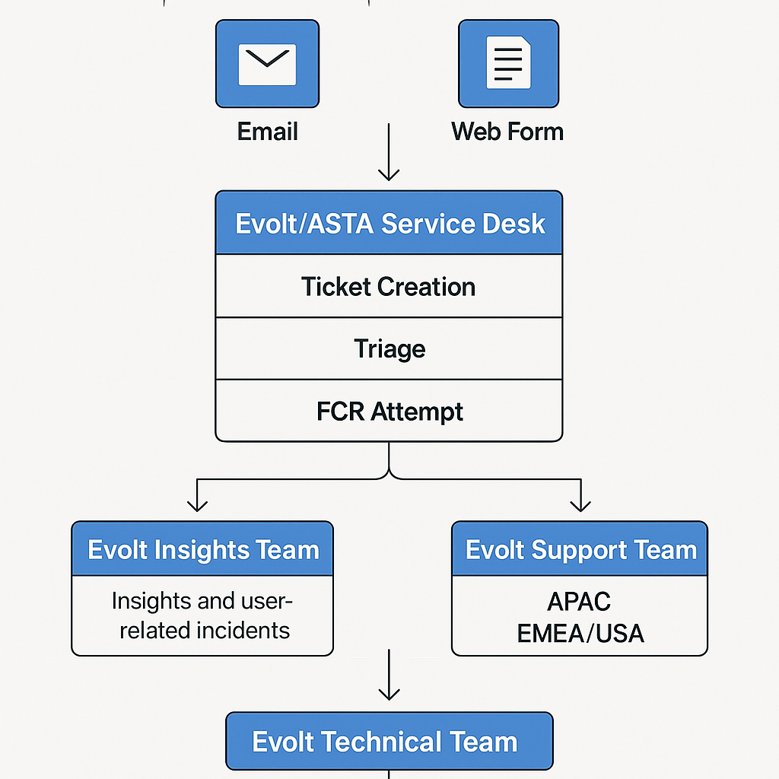

# Insights Team

The **Evolt Insights Team** is responsible for managing and supporting key components of the **Insights Platform**. Their scope includes:

* **Access to the Insights Platform**
* **Evolt API integrations**
* **Kiosk credentials**
* **App user credentials**
* **Data deletion requests**
* **General inquiries and issue resolution related to Insights**

While the Insights Team currently serves as a **second-line support** to ASTA, certain responsibilities will gradually transition to ASTA to streamline operations and improve response times.

* **To be confirmed (TBC)**
* **To be confirmed (TBC)**

These tasks will be clarified and documented as part of the evolving partnership.

The following responsibilities will **remain exclusively** with the Insights Team due to their sensitivity and access control requirements:

* **Access management**
* **Credential provisioning and updates**
* **Data deletion requests**

# Evolt Support Team

The **Evolt Support Team** operates across two regions:

* **Asia/Australia**: Monday to Friday, **9:00 AM – 5:00 PM (GMT+10)**
* **USA**: Monday to Friday, **9:00 AM – 5:00 PM (GMT-4)**

The Evolt Support Team serves as the **primary escalation point** for ASTA. Any incident that cannot be resolved during **first contact** should be escalated directly to Evolt Support.

The following types of requests should be sent to Evolt Support by default:

* **Warranty claims**
* **Faulty or replacement parts**
* **Technical issues involving Software Bugs or Issues unable to be fixed**
* **Pin Code (Partner Mode) Requests**

# Service Level Expectations

At present, Evolt does not operate under formal Service Level Agreements (SLAs). However, we do prioritize support for key partners.

The following customers are classified as high priority:

* **Anytime Fitness**
* **Revo**

For these partners, all incidents are expected to be resolved within **72 hours**.

For all other customers, Evolt operates on a **best-effort basis**, with a general resolution target of **72 hours**.

For further details on our support processes, including escalation procedures and customer communication standards, please refer to the **Evolt Support Expectations** document.

# Next Topic

The **adsfadfasdfadsfdasf**

**Platform Acess Requirements for ASTA**

* **HubSpot (CRM)** 
  + **Ticket Lodging and Customer Relations Documentation**
* **Microsoft Outlook**
  + **Inbox Management**
* **Microsoft Teams**
  + **For Internal Communcations with EVOLT**
* **TeamViewer- Might Require another License**
* **SendGrid**
  + **Require the ability to search Email Activity as well as fix/delete unsubscribed emails/ blocked or spam marked emails**
* **EVOLT Admin Dashboard**
  + **Permissions to be for VIEW ONLY of the following:**
    - **Machine Operator Credentials**
    - **Print template Version Confirmation**
    - **Member Account Details/ Scan Lookup**
    - **Insights Access Check (Email for Operator)**